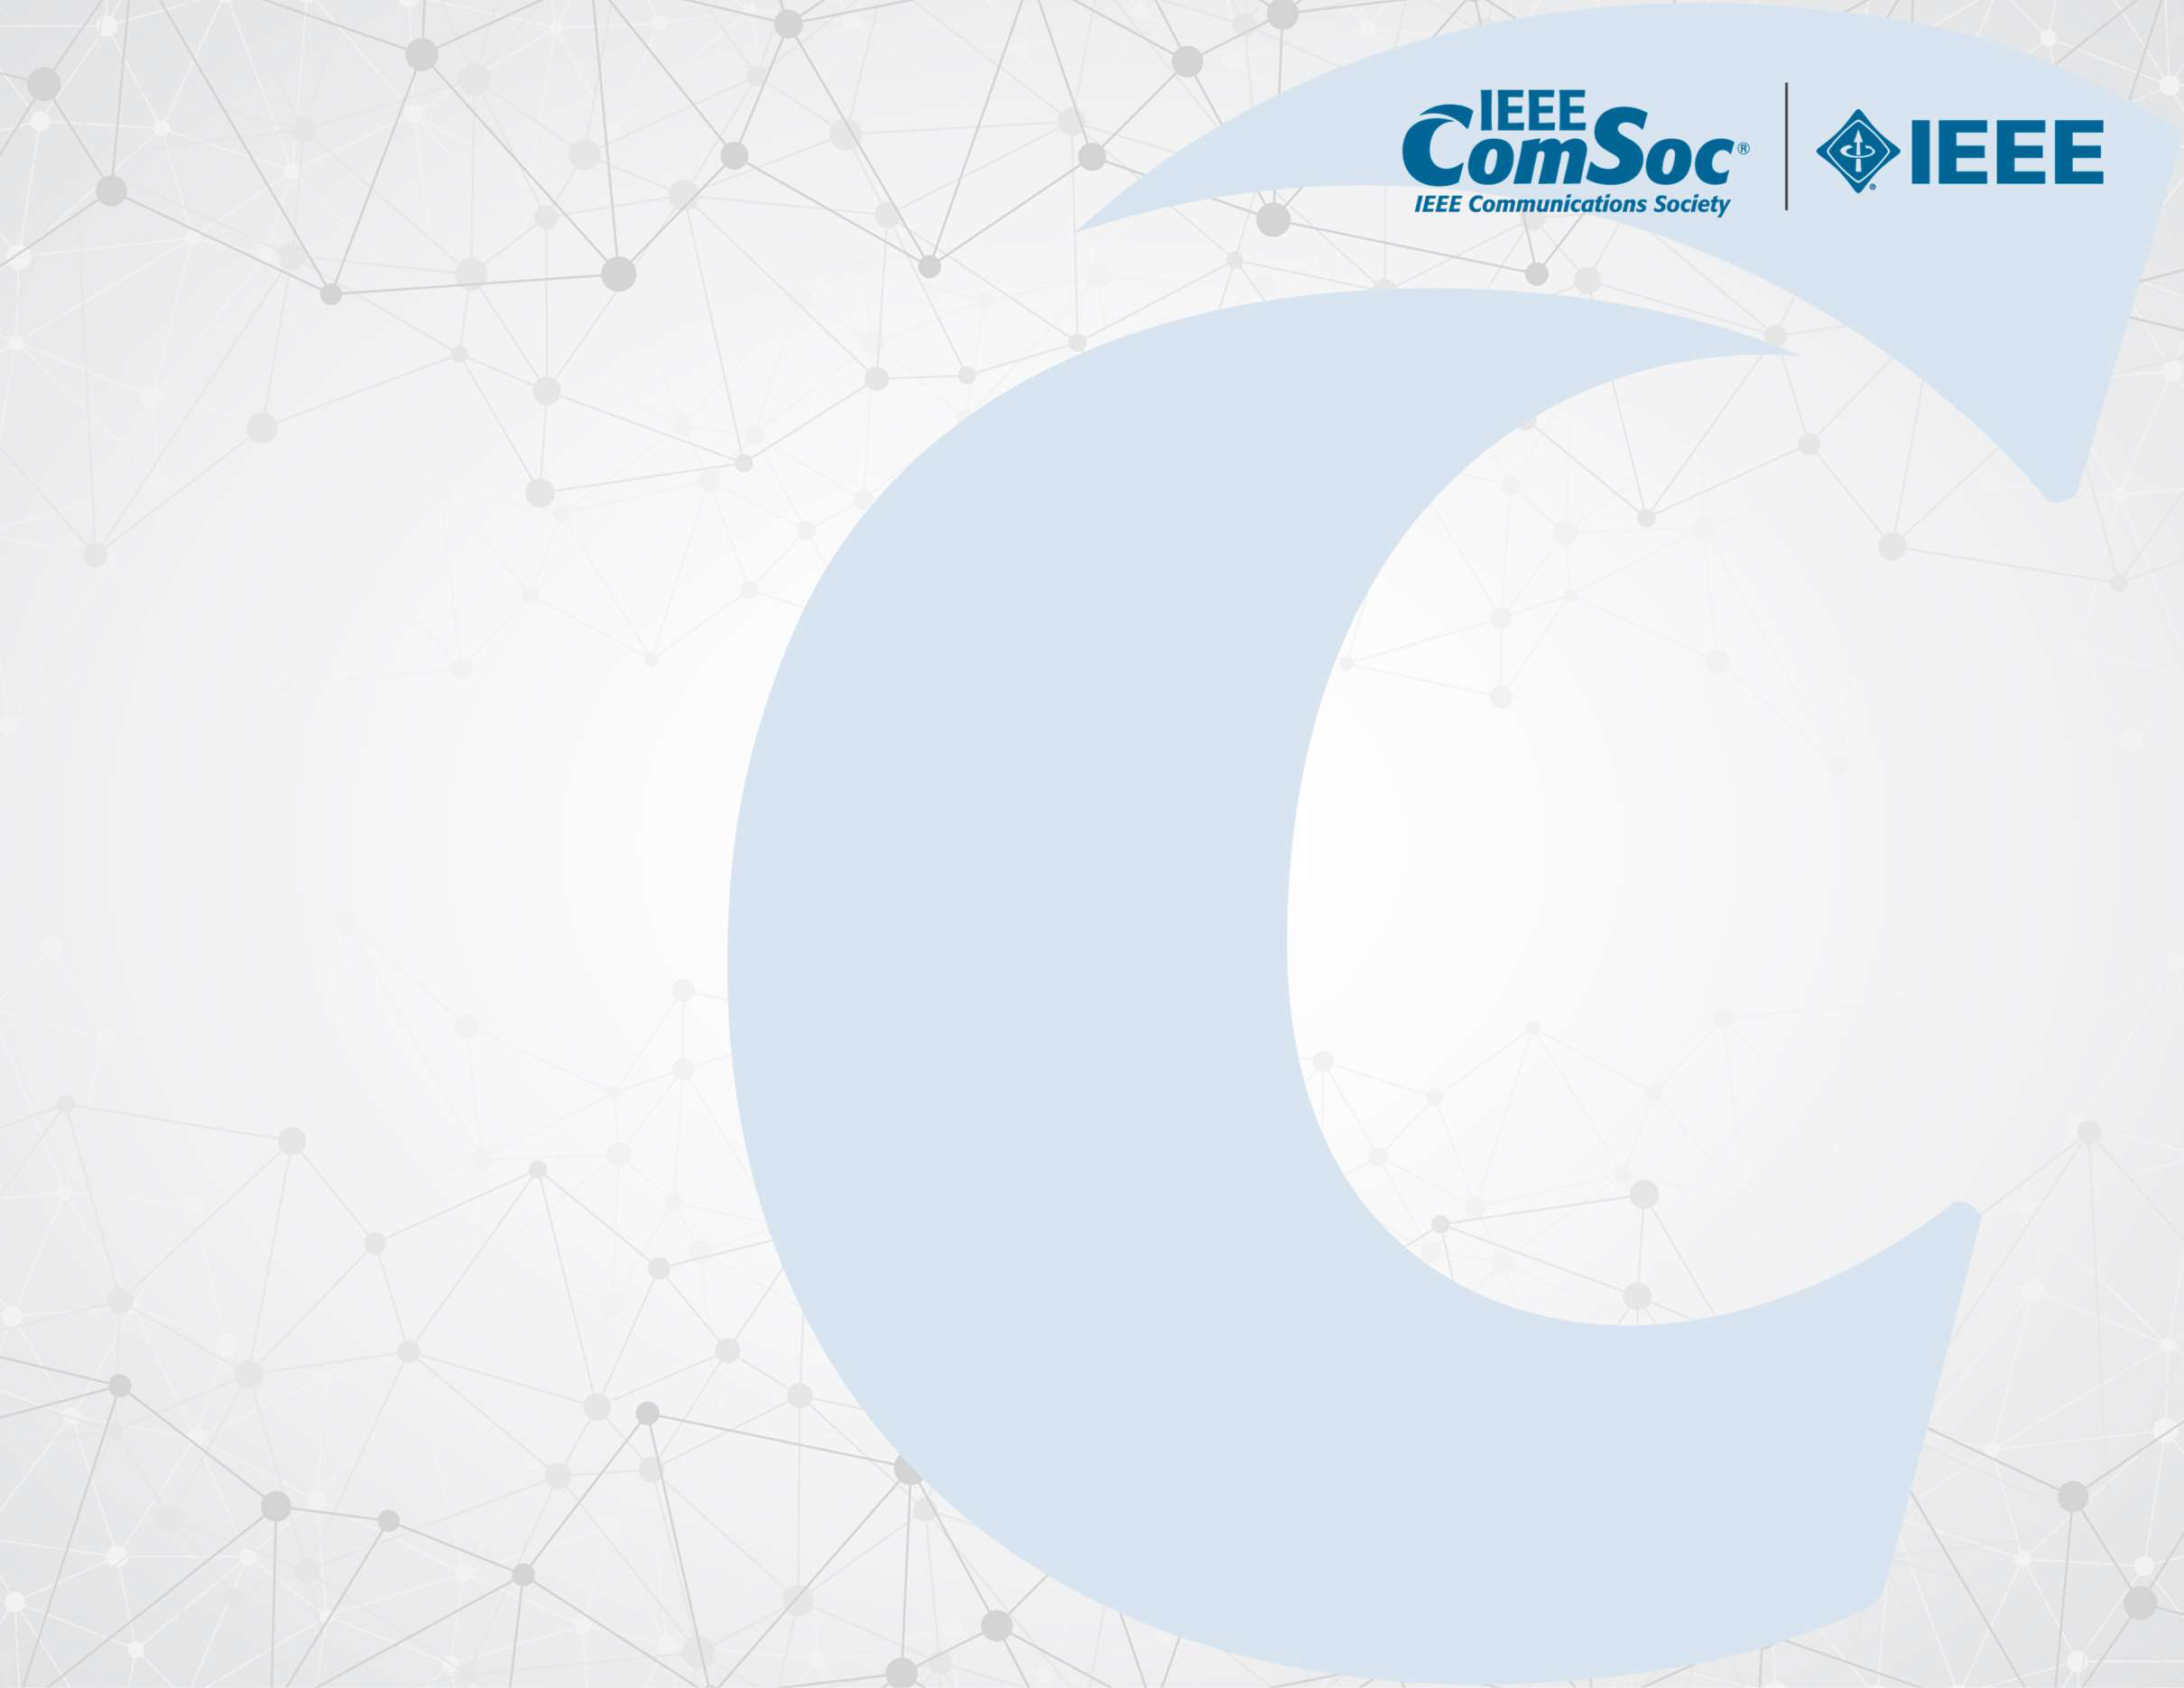

CERTIFICATE

OF PARTICIPATION

PRESENTED TO Name for attending

Name of Webinar

presented by

Dr. Arijit Roy, Dr. Ayan Mondal, and Prof. Sudip Misra

March 17, 2023

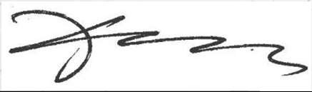

Xuemin (Sherman) Shen

IEEE Communications Society President

Wei Zhang, VP Technical & Educational Activities

IEEE Communications Society